**Marketing Email:**

Dear Donald Advertising National Korporation,

We are Apex, a team specializing in data analytics consulting. After analyzing New York City’s MTA data, we believe we can help you enhance your pricing and development strategy by optimizing billboard location and pricing. Our preliminary analysis reveals that there are significant monetizable opportunities in the digital advertising space. We’ve identified new locations and unexpected timeslots where you can maximize your return from billboard timeslots.

We hope to hear from you soon!

Sincerely,

Apex

**Reply from The Donald:**

I only work with the best people and I can tell you are the BEST people. Please call my secretary and work out a cofefe.

**Problem Statement:**

The Donald Advertising National Korporation owns several dozen digital billboards throughout the city of New York. They sell digital billboard advertising space by two hour slots. Currently, their pricing schema is based solely on the time the ad shows. With our data, they can develop a dynamic pricing strategy that increases their pricing for high-traffic billboard timeslots. This data can also help them identify ideal locations to place new digital billboards based on cumulative annual traffic and move billboards that can be placed better. At the center of their new pricing and development strategy, our study of turnstile data can help make D.A.N.K. great again.

**Results:**

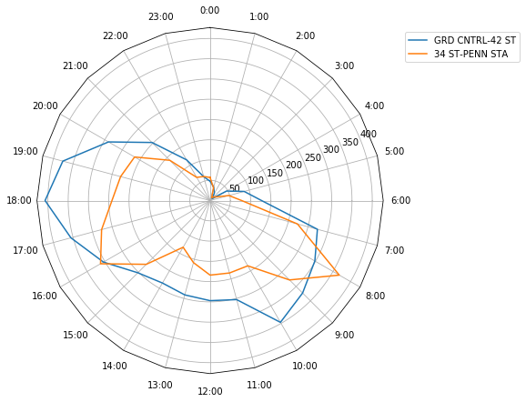

There are some regularities in the foot traffic data across stations. The first figure shows peaks in traffic corresponding to commute times for the Grand Central and Penn stations. Naturally, any dynamic pricing strategy would incorporate the increased traffic during these times.

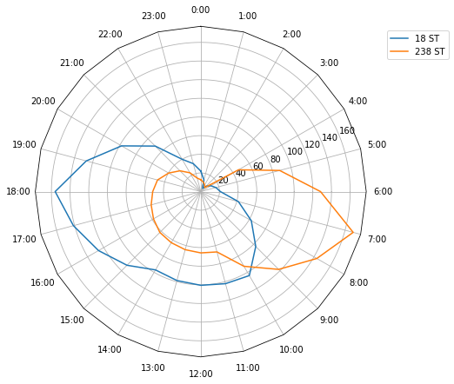

There are some Stations that break the mold. Above, the 18th St station has a strong evening commute and weak morning commute, while the 238th St station has the opposite. Our analysis will help you to find and exploit these small irregularities in your pricing strategy.

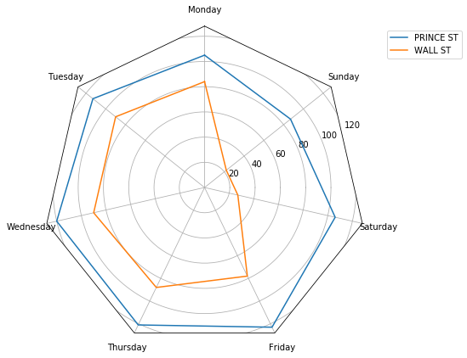

The foot traffic around most stations drops off on the weekends. This is exemplified by the Wall St station in the financial district. There are some stations where the foot traffic remains high during the weekend including the pictured Prince St station in SoHo. Armed with this data, you could demonstrate the value of weekend time slots to your clients.



The circle radius in the above GIF represents the total foot-traffic in and out of subway stations. The first daily increase in traffic begins in the suburbs around 6AM and transitions to downtown through about 12PM. The traffic leaving downtown and midtown is quite steady until around 7PM whereupon the traffic steadily declines till the next morning. It only includes the 73 stations that were automatically identified by the find_closest_match function.

**Future**

Since The Donald accepted our offer as “the best”, we will be adding the remaining, roughly 330 stations to the map. Additionally, we will provide the algorithm to price the billboard slot dynamically to maximize the profit. The price of billboard slot is related to number of potential customers who can see the advertisement displayed by the billboard. The current model is mainly based on the subway traffic changing with day and week for different locations. To optimize our model, we will look into other factors that may affect the prices:

1. Street traffic and foot traffic. We will look for the data sources which can provide information regarding people flow surrounding the station. MTA Bus data of NYC are available at<https://github.com/Bus-Data-NYC/mta-bus-archive>. The information mentioned above can help us to better evaluate the number of people who will see the billboard.

2. Event Schedule. Determining the price of the billboard slot for a certain time period should also consider real-world events. For example, during basketball season, the relative price of basketball-related ads should be increased.

3. Socio-Demographic data. For targeted advertising we will look for the socio-demographics of the people entering and exiting the station and the billboards can target the specific audience accordingly.

4. Predictive Modelling. Based on the current turnstiles, we can give you our approximate predictions in advance for next month which can really help you plan your budgets and targeting customers in advance.

5. Flows for MTA routes. Calculating entries and exits for each and every station will make us define the route with maximum traffic and can really you identify best locations to advertise targeting the majority.

**Conclusion**

Our analysis of the foot traffic in NYC will prove extremely useful to your company:

1. Inform prospective clients, bringing top dollar for each time slot.
2. Create dynamic pricing strategy which guarantees clients receive exactly the value they pay for.
3. Locate new spots for billboards.
4. Assist in negotiating the rental of billboard locations.